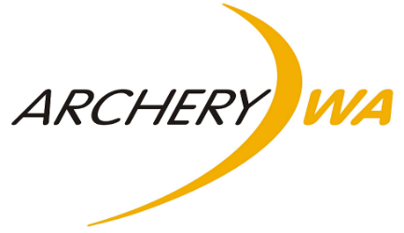
State Team
Selection Criteria
To be considered for selection for Youth State Team or Senior State Team applicants must meet the following criteria.

- Applicants need to be active members at events held in WA and be financial members of Archery WA and an affiliated WA Club.

- Any division (bow type) will be eligible for selection to the State Team. The Youth Team includes U14, U16, U18 and U21 classes and the Senior Team includes Open, 50+, 60+ and 70+ classes. At the discretion of the Selection Panel, archers who are in the U14, U16, U18 and U21 classes may be included in the Senior State Team.

- Submission of qualifying scores of 2 x outdoor target scores and 1 x field score for Field Teams and 3 x outdoor target scores for Target Teams are required to be submitted by the closing date, to the AWA State Recorder. These scores must have been shot within the last 12 months.

- For Senior State Team

- The qualifying scores have to meet a minimum Gold classification for Recurve, Barebow Recurve and Longbow Divisions; and a minimum Master Bowman classification for Compound and Barebow Compound Divisions.

- Qualifying scores can be shot at QREs (maximum 2 of the 3 submitted scores), State Tournaments, Interstate Tournaments, or International Tournaments. No club scores are permitted.

- Scores must be from a qualifying outdoor target event; State/National indoor target scores will not be considered.

- For Youth State Team

- The qualifying scores have to meet a minimum Red classification if shot at QRE’s (no maximum number of submitted scores), State Tournaments, Interstate Tournaments, or International Tournaments.

- The qualifying scores have to meet a minimum Gold classification if shot at a club event (maximum 2 of the 3 submitted scores) held under Archery Australia shooting conditions.

- Scores must be from a qualifying outdoor target event; State/National indoor target scores will not be considered.

- Top 4 people in each Division will be placed into the team, for any division with more than 4 archers applying, reserves may be considered at the discretion of the Selection Panel.

- The Executive Committee will appoint 3 people to the Selection Panel. This will include the State Recorder, Development Officer and one other.

- The teams will be selected 3 months prior to the event where possible.

- Team Members will receive a re-imbursement* for the entry fee and a State Team uniform as appropriate.

- Once selected, team members will commit to any training that is required from the Selection Committee, Appointed Coaches and/or Team Managers. Failure to comply with this policy is grounds for removal from the State Team at the discretion of the Selection Panel.

*Reimbursement is only valid if the athlete competes in all events at the Youth or Senior National Tournament they are representing Archery WA at.

