Strategic Plan

2018
2020

Core Values: Governance, Excellence,
Participation, Sustainability.
Archery WA email: development.archerywa@gmail.com phone: (08 9248 8585)

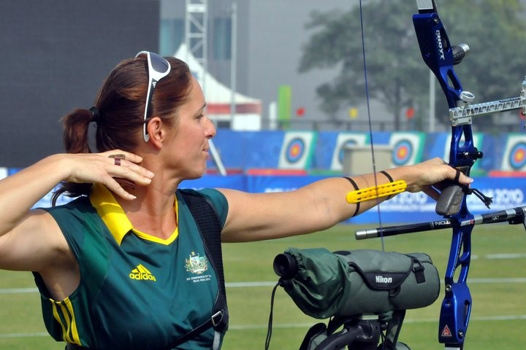
Vision Statement
To foster the enjoyment of archery at all levels.
Our Mission
Archery WA will develop and promote quality opportunities to members to participate and contribute towards the growth and modernisation of the sport throughout the state.

Key Strategic Areas
- Participation and Development
- Sustainability
- Growth to High Performance
- Organisational Excellence

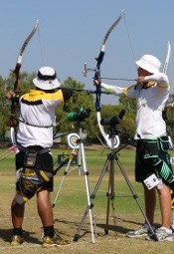
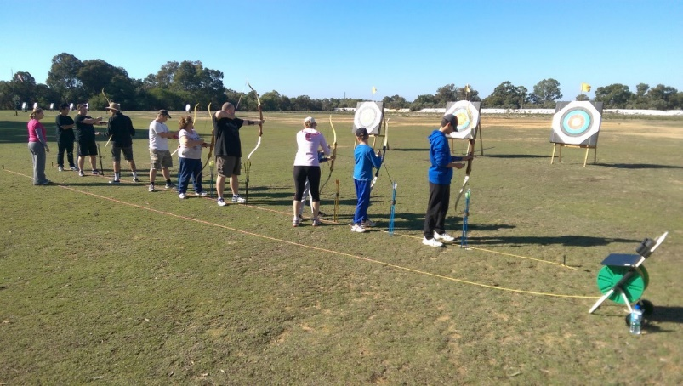
Participation and Development

To grow participation of archery state wide. Archery will be inclusive by providing increased opportunities at all levels.
- Implement school programs in WA
- Cater for all capabilities as well as increase usage of the Archery Park
- Events are conducted for all member ability levels
- Develop identified programs to increase membership at all stages
- Promote a fresh social culture in our sporting community

Sustainability

Maintain and support current members and promote strong club communities.
- Promote and develop the sport at the grassroots level
- Nurture current membership numbers
- Grow membership by 10% each year
- Provide clubs support with coaching and "Come 'N' Try'' programs

Growth to High Performance

Provide opportunities to our members to reach their performance potential and goals.
  - Provide elite athletes with high calibre coaching
  - Develop support structures for High Performance athletes in alliance with Archery Australia’s development pathway
  - Access funding and sponsorship opportunities
  - Identify other training required by clubs to promote juniors to High Performance

Organisation Excellence

To build a sustainable and prosperous organisation by increasing capacity to govern the sport.
- Ensure greater financial growth and stability
- Build strategic partnerships with government and identified organisations for growth potential
- Provide support to develop strong governance qualities within the committee structure
- Improve communication to all clubs
- Encourage volunteer support across Archery WA and our affiliated clubs

